- Find a real Flutter developer job posting on LinkedIn or Naukri.com and list 3 skills or technologies mentioned in the requirements section.
Flutter Developer Job Posting
Company: InheritX Solutions Pvt. Ltd.
Position: Jr. Flutter Developer
Location: Ahmedabad, Gujarat, India
Source: LinkedIn
3 skills/technologies mentioned in the requirements:
- Flutter & Dart – Knowledge of Flutter framework and Dart programming language.
- Firebase – Experience with Firebase services such as Authentication, Firestore, FCM, Crashlytics, and Analytics.
- REST APIs & JSON – Experience working with REST APIs and handling JSON data.
- Draw a simple diagram (on paper or using any online tool) showing how a mobile app team is structured in a typical company, including at least: mobile developer, designer, backend/API developer, tester, and product manager.
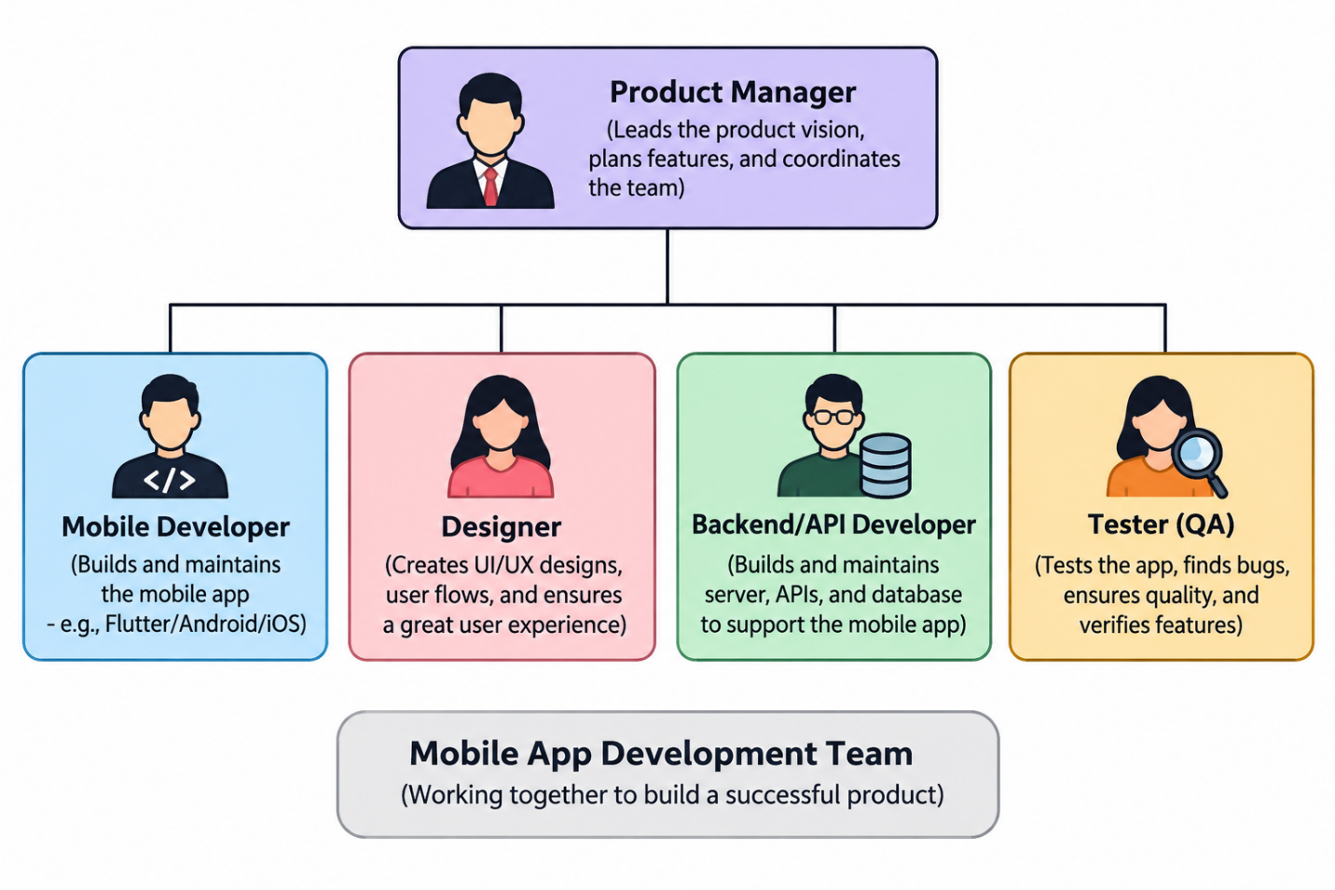
- Pick any app you use daily (like Zomato, Instagram, or Flipkart) and write a short feature request as if you were the product manager. Then, briefly describe which team members (designer, backend, mobile developer, tester) would be involved in delivering this feature and what each would do.

Feature Request – Flipkart
App: Flipkart
Role: Product Manager
Feature: Smart Delivery Tracking
Feature Request
I would like to introduce a Smart Delivery Tracking feature in the Flipkart mobile app. This feature will allow customers to see the real-time location and estimated arrival time of their order on a map. Users will also receive notifications when the delivery partner is nearby.
Team Members Involved
- Designer: Designs the delivery-tracking screen, map interface, order status, and notification experience to make the feature simple and easy to use.
- Backend/API Developer: Develops the APIs required to provide real-time delivery location, order status, and estimated delivery time. They also connect the app with delivery-partner systems.
- Mobile Developer: Implements the tracking screen and map in the Flipkart mobile app, connects it with the backend APIs, and handles real-time updates and notifications.
- Tester (QA): Tests the feature on different devices and network conditions, checks location updates and notifications, and identifies bugs before the feature is released.
Expected Benefit
This feature would help customers easily track their orders and know approximately when their delivery will arrive, improving the overall shopping experience.

- Watch a walkthrough video of a production Flutter app (find one on YouTube, such as an open-source app demo) and write down 3 features you think a junior Flutter developer would be responsible for building or maintaining in their first 3 months. Hint: Look for features like login screens, list views, or profile editing.

Flutter Production App – Junior Developer Responsibilities
Video watched: Flutter Complete Production App Tutorial – YouTube
After watching the production Flutter app walkthrough, I think a junior Flutter developer could be responsible for the following features during their first three months:
1. Login and OTP Authentication
A junior developer could build and maintain the login screen, handle user input and validation, implement OTP verification, and connect the screen with the authentication API/Firebase.
2. Product List and Grid View
The developer could create product listing screens using Flutter widgets such as ListView and GridView. They could also display product information received from the backend and maintain the UI when products are added or updated.
3. Product Filtering and Sorting
The developer could implement basic filters such as category, brand, and price range and add sorting functionality. They would connect these controls to the existing product data and make sure the results update correctly.
Conclusion
These features are suitable for a junior Flutter developer because they involve common Flutter tasks such as building UI screens, handling user input, displaying dynamic data, connecting APIs/Firebase, and fixing UI bugs.

